Lab 08

Q1.

views.py

from django.shortcuts import render

def car_form(request):

return render(request, 'car_app/car_form.html')

def car_result(request):

if request.method == 'POST':

manufacturer = request.POST.get('manufacturer')

model = request.POST.get('model')

return render(request, 'car_app/car_result.html', {'manufacturer': manufacturer, 'model': model})

return render(request, 'car_app/car_form.html')

car_form.html

<!DOCTYPE html>

<html lang="en">

<head>

<meta charset="UTF-8">

<meta name="viewport" content="width=device-width, initial-scale=1.0">

<title>Car Manufacturer Form</title>

</head>

<body>

<h1>Select a Car Manufacturer and Model</h1>

<form method="POST" action="{% url 'car_app:car_result' %}">

{% csrf_token %}

<label for="manufacturer">Select Car Manufacturer:</label>

<select name="manufacturer" id="manufacturer">

<option value="Toyota">Toyota</option>

<option value="Honda">Honda</option>

<option value="BMW">BMW</option>

<option value="Ford">Ford</option>

<option value="Tesla">Tesla</option>

</select><br><br>

<label for="model">Enter Car Model:</label>

<input type="text" name="model" id="model" required><br><br>

<input type="submit" value="Submit">

</form>

</body>

</html>

car_result.html

<!DOCTYPE html>

<html lang="en">

<head>

<meta charset="UTF-8">

<meta name="viewport" content="width=device-width, initial-scale=1.0">

<title>Car Manufacturer Result</title>

</head>

<body>

<h1>Car Manufacturer and Model Selected</h1>

<p>Car Manufacturer: {{ manufacturer }}</p>

<p>Car Model: {{ model }}</p>

<a href="{% url 'car_app:car_form' %}">Go Back</a>

</body>

</html>

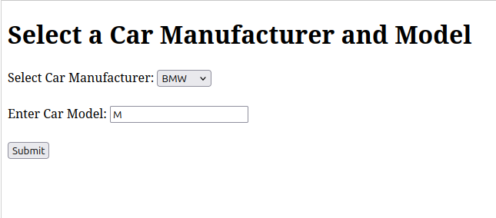

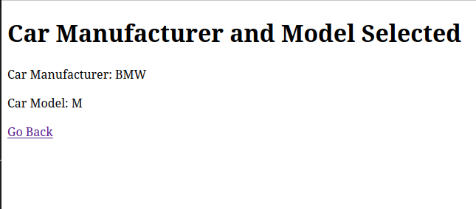  
  
  
Q2.   
  
  
Views.py

from django.shortcuts import render, redirect

def first_page(request):

return render(request, 'student_app/firstPage.html')

def second_page(request):

if request.method == 'POST':

request.session['name'] = request.POST.get('name')

request.session['roll'] = request.POST.get('roll')

request.session['subject'] = request.POST.get('subjects')

name = request.session.get('name', '')

roll = request.session.get('roll', '')

subject = request.session.get('subject', '')

return render(request, 'student_app/secondPage.html', {

'name': name,

'roll': roll,

'subject': subject,

})

firstPage.html

<!DOCTYPE html>

<html lang="en">

<head>

<meta charset="UTF-8">

<meta name="viewport" content="width=device-width, initial-scale=1.0">

<title>First Page</title>

<style>

body {

font-family: Arial, sans-serif;

background-color: #f4f4f9;

margin: 0;

padding: 0;

}

h1 {

text-align: center;

color: #333;

margin-top: 50px;

}

.container {

width: 40%;

margin: 0 auto;

background-color: white;

padding: 30px;

border-radius: 8px;

box-shadow: 0 4px 8px rgba(0, 0, 0, 0.1);

}

label {

font-size: 16px;

margin-bottom: 8px;

display: block;

color: #333;

}

input[type="text"], select {

width: 100%;

padding: 12px;

margin: 8px 0 20px 0;

border-radius: 5px;

border: 1px solid #ddd;

box-sizing: border-box;

}

input[type="submit"] {

background-color: #4CAF50;

color: white;

padding: 15px 20px;

border: none;

border-radius: 5px;

width: 100%;

font-size: 16px;

cursor: pointer;

transition: background-color 0.3s ease;

}

input[type="submit"]:hover {

background-color: #45a049;

}

.form-group {

margin-bottom: 20px;

}

.back-link {

text-align: center;

margin-top: 20px;

}

</style>

</head>

<body>

<div class="container">

<h1>Enter Your Details</h1>

<form method="POST" action="{% url 'student_app:second_page' %}">

{% csrf_token %}

<div class="form-group">

<label for="name">Name:</label>

<input type="text" id="name" name="name" required>

</div>

<div class="form-group">

<label for="roll">Roll No:</label>

<input type="text" id="roll" name="roll" required>

</div>

<div class="form-group">

<label for="subjects">Select Subject:</label>

<select name="subjects" id="subjects">

<option value="Math">Math</option>

<option value="Science">Science</option>

<option value="English">English</option>

<option value="History">History</option>

</select>

</div>

<input type="submit" value="Submit">

</form>

</div>

</body>

</html>

secondPage.html

<!DOCTYPE html>

<html lang="en">

<head>

<meta charset="UTF-8">

<meta name="viewport" content="width=device-width, initial-scale=1.0">

<title>Second Page</title>

<style>

body {

font-family: Arial, sans-serif;

background-color: #f4f4f9;

margin: 0;

padding: 0;

}

h1 {

text-align: center;

color: #333;

margin-top: 50px;

}

.container {

width: 50%;

margin: 0 auto;

background-color: white;

padding: 30px;

border-radius: 8px;

box-shadow: 0 4px 8px rgba(0, 0, 0, 0.1);

}

p {

font-size: 18px;

color: #333;

line-height: 1.6;

text-align: center;

}

.back-link {

text-align: center;

margin-top: 20px;

}

input[type="submit"] {

background-color: #4CAF50;

color: white;

padding: 15px 20px;

border: none;

border-radius: 5px;

width: 100%;

font-size: 16px;

cursor: pointer;

transition: background-color 0.3s ease;

}

input[type="submit"]:hover {

background-color: #45a049;

}

</style>

</head>

<body>

<div class="container">

<h1>Details Submitted</h1>

<p><strong>Name:</strong> {{ name }}</p>

<p><strong>Roll No:</strong> {{ roll }}</p>

<p><strong>Subject:</strong> {{ subject }}</p>

<form method="GET" action="{% url 'student_app:first_page' %}">

<input type="submit" value="Go Back to First Page">

</form>

</div>

</body>

</html>

